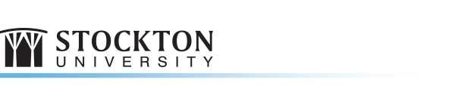
Noyes Arts Garage of Stockton University:
Korean Lantern Exhibition & Free Workshops

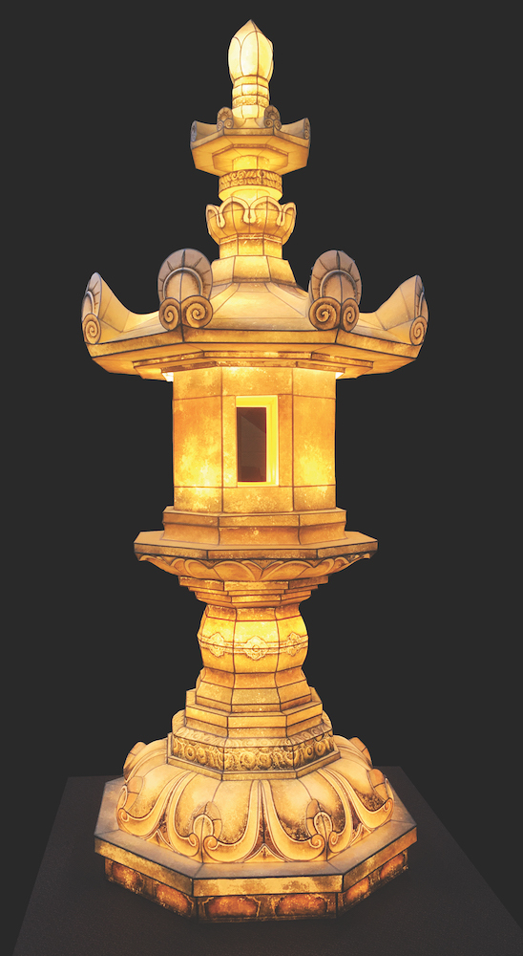
For Immediate Release; with photos on Flickr and captions below
Friday, November 16, 2018

NOYES ARTS GARAGE, ATLANTIC CITY, N.J. - The Noyes Arts Garage of Stockton University presents the KOREAN LANTERN EXHIBITION: OPEN-HEARTS IN LIGHTS. This unique exhibition of exquisite traditional and contemporary Korean paper lanterns runs from October 20 - December 1, 2018. Korean paper lantern-making workshops, open to the public, will be offered on Thursday, November 29, from 2:30 - 4:20 pm, on the Stockton Campus in Galloway, C/D Atrium (between C & D Wings and on Saturday, December 1, 4 - 6 pm, at The Noyes Arts Garage of Stockton University. Limited seating.

The lanterns form part of the Lotus Lantern Festival, a Korean national holiday, also known as Yeondeunghoe or the “Feast of Lanterns.” Hundreds of thousands of candlelit paper lanterns are raised throughout the country to celebrate the birthday of Buddha. These decorative lanterns are suspended in the front of every household, one lantern for each family member, with their names and prayers written on narrow sheets of white paper that sway gently from the base of the lanterns.
Hwaumsa Stand Lantern

This exhibition of traditional Korean lanterns comes to the Noyes Arts Garage directly from South Korea through the efforts of the Yeon Deung Hoe Preservation Committee and Jongbok Yi, Associate Professor of Asian Philosophy, of Stockton University. The Yeon Deung Hoe Preservation Committee is working to revive traditional lantern making, and has researched and recreated many Korean traditional lantern designs. (Photos 1-5)

More -

- Continued from page 1

NOYES GALLERY, THE NOYES ARTS GARAGE, ATLANTIC CITY:
Current Exhibitions:
- RAW 2018: PHOTOGRAPHY EXHIBITION September 28, 2018 - January 26, 2019
- KOREAN LANTERN EXHIBITION: OPEN-HEARTS IN LIGHTS October 20 – December 1, 2018

Upcoming Events:
- Small Business Saturday, Noyes Arts Garage, A.C. November 24
- Korean Paper Lantern-Making Workshop, Stockton Campus - Galloway November 29
- Korean Paper Lantern-Making Workshop, Noyes Arts Garage, A.C. December 1
- Second Friday: Holiday Party -Noyes Arts Garage, A.C. (Open to Public) December 14
- World Above Poetry Night December 12
- Third Thursday: Noyes Galleries, Hammonton (Free & Open to Public) December 20

Photos 1-5 Captions:
- KOREAN LANTERN EXHIBITION: OPEN-HEARTS IN LIGHTS - Hwaumsa Stand
- KOREAN LANTERN EXHIBITION: OPEN-HEARTS IN LIGHTS - Multiple Lanterns on Poles
- KOREAN LANTERN EXHIBITION: OPEN-HEARTS IN LIGHTS - Geumsansa Pagoda
- KOREAN LANTERN EXHIBITION: OPEN-HEARTS IN LIGHTS - Dragon
- KOREAN LANTERN EXHIBITION: OPEN-HEARTS IN LIGHTS - Turtle

ABOUT:
1. Noyes Museum Galleries, Stockton’s Kramer Hall, 30 Front St., Hammonton, N.J. 08037 • (609) 626-3420 • www.noyesmuseum.org
2. Noyes Arts Garage: 2200 Fairmount Ave., Atlantic City, N.J. 08401 • (609) 626-3805 • http://www.artsgarageac.com
3. Noyes Gallery, Seaview Resort: 401 S. New York Rd., Galloway, N.J. 08205 • (609) 626-3420
4. Noyes Gallery, The Claridge Hotel: The Boardwalk & Park Place, Atlantic City, N.J. 08401 • (844) AC IS FUN • (844) 224-7386

Contact:
Saskia Schmidt
Noyes Museum Director of Education
Hammonton, NJ 08037
Saskia.Schmidt@stockton.edu
(609) 626-3420

# # #

