Education Guide September 19th – December 11th, 2022

Nolan Ryan Pop-Up Exhibit
Opening Reception:
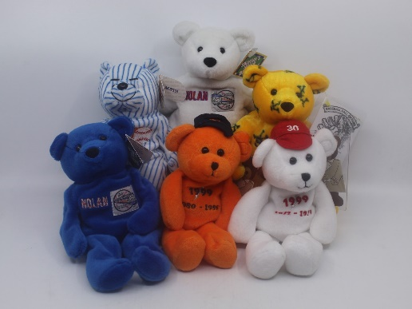
October 17th, 2022, 5:30
Baseballs, bats, gloves, hats, jerseys, and cards. These are just some of the nearly 15,000 items comprising Leo S. Ullman’s vast Nolan Ryan collection. Ullman, a real estate investor and former owner of the Shore Mall in Egg Harbor Township donated his collection, which is believed to be the largest of its kind and is appraised as worth more than $1 million, to the university this year.
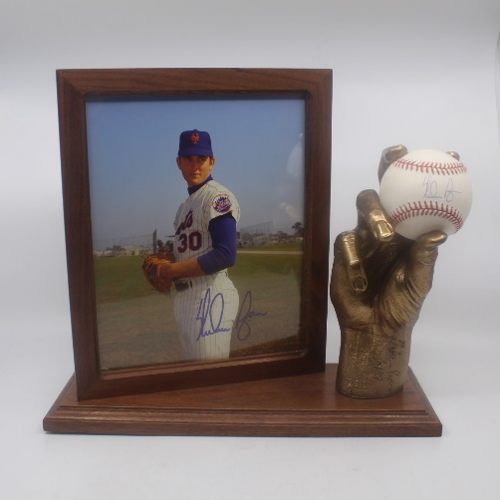
Items in the Nolan Ryan pop-up highlight Ryan’s 27-year career pitching for teams such as the New York Mets, California Angels, Houston Astros, and Texas Rangers, and include a signed cowboy hat, an autographed horse saddle, a blood-stained jersey and even Beanie Babies. This unique assortment of memorabilia is on display at five Stockton University locations: Stockton’s campuses in Galloway, Atlantic City, and Manahawkin along with Kramer Hall in Hammonton and the Noyes Arts Garage. The largest display is at the Arts Garage, in which the walls of the room are painted in the orange and blue colors of the Houston Astros, the team that Ryan spent nine years with. The exhibit at Kramer Hall features display cases and wall art. Other items, including hats and statutes, are on display in Manahawkin and on the second floor of the John F. Scarpa Academic Center in Atlantic City. Throughout all the sites are cards detailing Ryan’s career and lesser-known facts about his life, including that he would soak his fingers in pickle juice between games to help prevent blisters.
Perhaps the most unusual item is a blood-stained jersey (reproduction), signed by Ryan, that he wore while pitching for the Texas Rangers in 1990. In a classic example of Ryan’s legendary toughness, the Hall of Famer took a line drive to the face off a ground ball by Bo Jackson. Ryan threw Jackson out at first but had a bloody lip. Ryan stayed in the game for another 17 outs, blood on the front of his jersey and striking out eight batters in seven innings.

The Noyes Museum of Art of Stockton University · http://www.noyesmuseum.org · (609) 626-3420
The Noyes Arts Garage of Stockton University · www.artsgarageac.com · (609) 626-3805
Check us out on Facebook, Twitter, Instagram and YouTube.

