The Noyes Arts Garage of Stockton University
2200 Fairmount Ave., Atlantic City, NJ 08401 • (609) 626-3805 • artsgarageac.com

Press Release For Immediate Release
Media Contact: Sara Gendlek, Assistant Director July 8, 2016
publicrelations@noyesmuseum.org
(609) 652-8848 ext. 308

GRAND VISTA: 21st Century Landscapes
Guest-Curated Group Exhibition at Noyes Arts Garage in Atlantic City

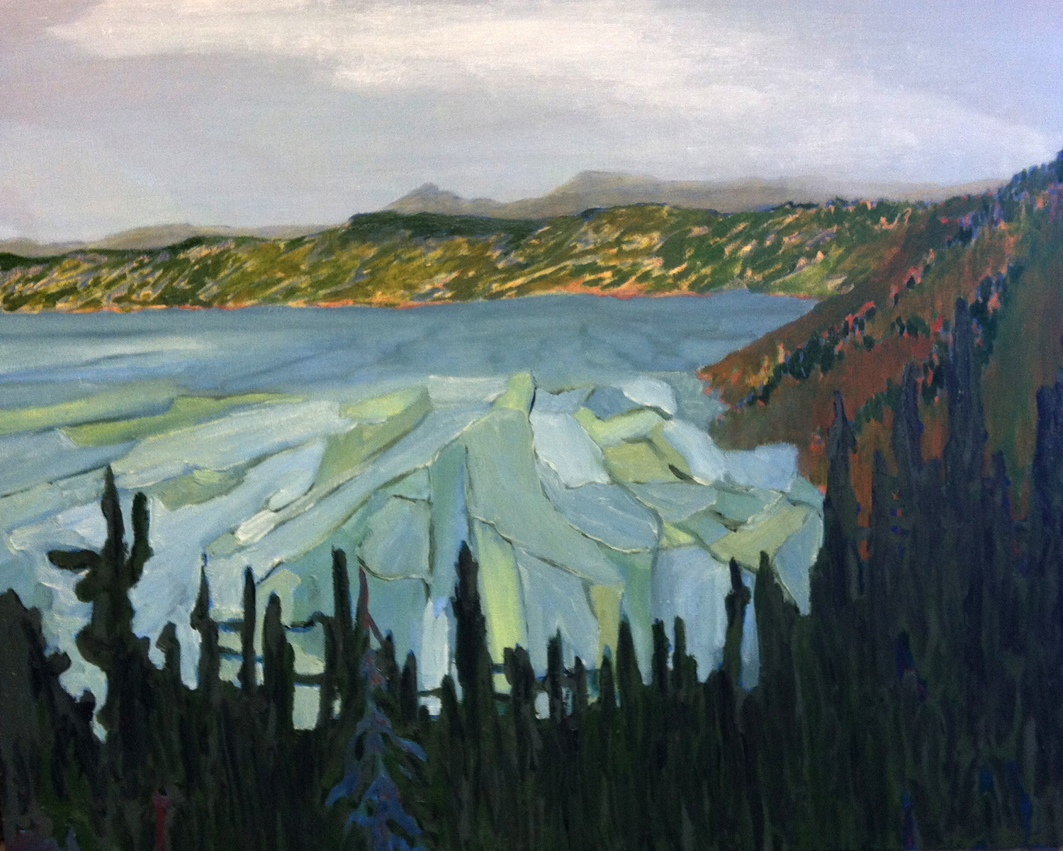
ATLANTIC CITY, NJ – The Noyes Museum of Art of Stockton University is pleased to host an exhibition of recent work by Wes Sherman, Gary Stephan, Ilse Murdock, Judy Simonian and Aaron Williams at the Noyes Arts Garage in Atlantic City. Guest-curated by native New Jersey artists Danielle Wolfrum and Wes Sherman, these artworks investigate landscape painting as an enduring theme in genre painting in the twenty-first century. The artwork will be on view from August 5 – October 30, 2016.

The five artists in this exhibition approach the subject matter with distinct points of view. Aaron Williams combines stock images of iconic natural landscapes with abstract painting techniques to reshape the relationship the viewer holds with these famous places. Gary Stephan’s geometrically precise brushstrokes belie the organic inspiration behind his paintings, redesigning the landscape in a more industrial way. Judy Simonian uses the landscape as a vehicle for expression, carrying over themes of disorientation and hope from her larger body of work. Conversely, Ilse Murdock paints within nature in order to directly situate herself and her audience as part and parcel of the larger natural world, and to indelibly tie the preservation of nature to her own artistic process. It is artist and exhibition curator Wes Sherman whose works adhere most closely to the landscape genre, with impressionistic views to guide us along the same paths Sherman travelled when he took in the vistas himself.
Wes Sherman, Crater Lake (NPP#120-21),
Oil on canvas

A free opening reception will be held on Friday, August 12, 6:00-8:00 p.m. during Second Friday at the Noyes Arts Garage of Stockton University at 2200 Fairmount Avenue, Atlantic City, NJ 08401. For more information call (609) 626-3805 or visit artsgarageac.com.

About:
The Noyes Museum of Art was founded in Oceanville, NJ, in 1983 to collect, preserve, and exhibit American fine and folk art, with an emphasis on New Jersey artists and folk art forms. Today, the Noyes Museum’s exhibitions reflect the area’s cultural heritage, while also presenting significant artwork by regional and national artists working in a variety of media. The Noyes has also expanded to include galleries in Hammonton, Atlantic City, and at Seaview Resort in Galloway. The Noyes Shop: Hammonton, which opened in 2008, specializes in custom framing and can be reached at (609) 561-8006. The Noyes Gallery at Kramer Hall in Hammonton is the newest addition to the vibrant Arts District in Downtown Hammonton, and The Noyes Museum’s satellite exhibition spaces. It is located at 30 Front Street, Hammonton, NJ 08037. In February 2010, The Noyes Museum of Art formed a partnership with Stockton College (now Stockton University) to form The Noyes Museum of Art of Stockton University. Through a 2013 partnership with the CRDA, The Noyes Museum opened The Noyes Arts Garage of Stockton University, a unique multi-use arts and retail space at 2200 Fairmount Avenue in Atlantic City.

The Museum remains a 501 (c)(3) organization, with general funding provided by: the New Jersey State Council on the Art/Department of State, a state partner of the National Endowment for the Arts; the Mr. and Mrs. Fred Winslow Noyes Foundation; Stockton University; and the Geraldine R. Dodge Foundation.

Current & upcoming exhibitions from The Noyes Museum of Art:

The Noyes Museum at Kramer Hall, Hammonton:
Hammonton: 150 Years of Industry March 7 – August 8, 2016
Hammonton: 150 Years of Agriculture August 15 – December 31, 2016

The Noyes Arts Garage of Stockton University, Atlantic City:
The 2016 New Jersey Arts Annual: Fine Arts April 8 – July 28, 2016
Ed Kent: From My Garage June 30 – July 31, 2016
James Raczkowski: Night Visions June 30 – July 31, 2016
Grand Vista: 21st Century Landscapes August 5 – October 30, 2016
Hak Vogrin: A Retrospective August 5 – October 30, 2016

The Noyes Gallery at Seaview Resort, Galloway:
Diane Tomash: Plein-Air Paintings & Prints May 5 – August 28, 2016
Summerlands: Works from the Noyes Permanent Collection May 5 – August 28, 2016
Cathleen Engelsen: NJ Landmarks, Historical Paintings September 1, 2016 – January 8, 2017

