Noyes Museum of Art of Stockton University Announces Fall Events

For Immediate Release
Wednesday, October 19, 2016

Contact: Saskia Schmidt
Noyes Museum Director of Education
Galloway, N.J. 08205
education@noyesmuseum.org
(609) 626-3420

NOYES GALLERY AT KRAMER HALL, HAMMONTON
HAMMONTON, N.J. - During Hammonton’s Third Thursday event on Oct. 20, The Noyes Gallery at Stockton’s Kramer Hall at 30 Front Street will stay open late from 6 - 8 p.m. Be sure to visit the Hammonton: 150 Years of Agriculture exhibition, on view through Dec. 31, 2016. Utilizing artifacts and artists’ interpretations, this exhibition highlights 150 years of agriculture in Hammonton. The Noyes Gallery is free and open to the public
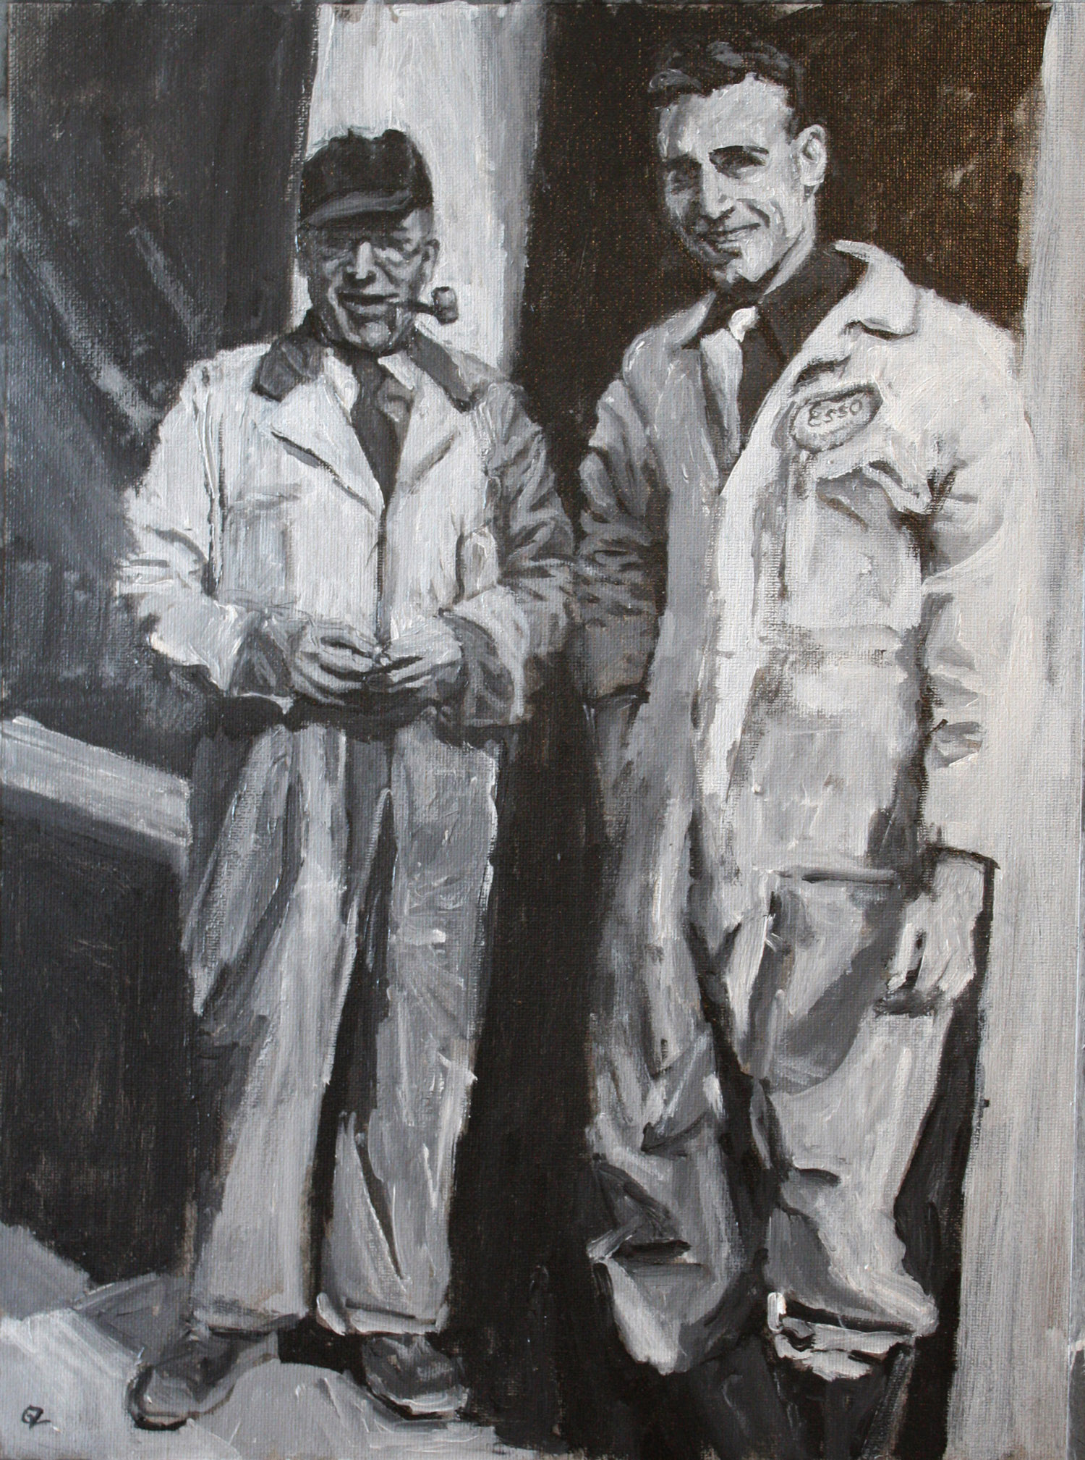
The Noyes Shop in Hammonton at 5 South Second Street is also open late on Oct. 20 from 6– 8 p.m., and will celebrate Third Thursday with a free craft, a special sale offer of 25% off your total purchases, and 50 percent off custom framing from now until Dec. 15! Noyes Shop staff will provide instructions on how to make your own Halloween or autumn-themed felt patches and pins.
For Hammonton’s Third Thursday on Nov. 17, The Noyes Gallery at Kramer Hall will host a free reception celebrating the opening of the Noyes Associate Artist Members Exhibition. This exhibition is on view from Nov. 9 through Jan. 15, 2017. Meet the artists and enjoy refreshments, wine, and cheese from 6- 8 p.m. The Noyes Associate Artist Members exhibition showcases the work of 13 artists creating outstanding artwork throughout the state. Works in mixed media, painting, and sculpture will be featured. This annual exhibition continues the tradition of celebrating recent work from
-more- Grace Zabelli, The Esso Men

-continued from page 1-

selected by jury to be a part of the prestigious Artist Member’s group. Noyes Associate Artists Members included in this exhibition are: Jacqueline Boyd, Charles Branigan, Vicky Culver, t.a. hahn, James Kent, Dennis Loughlin, Bill Parker, Glynnis Reed, Christina Sanes, Judith Saylor, Mary Trivelli Schatz, Grace Zambelli, and Michael Zabelli.

For more information call (609) 626-3420 or visit www.noyesmuseum.org.
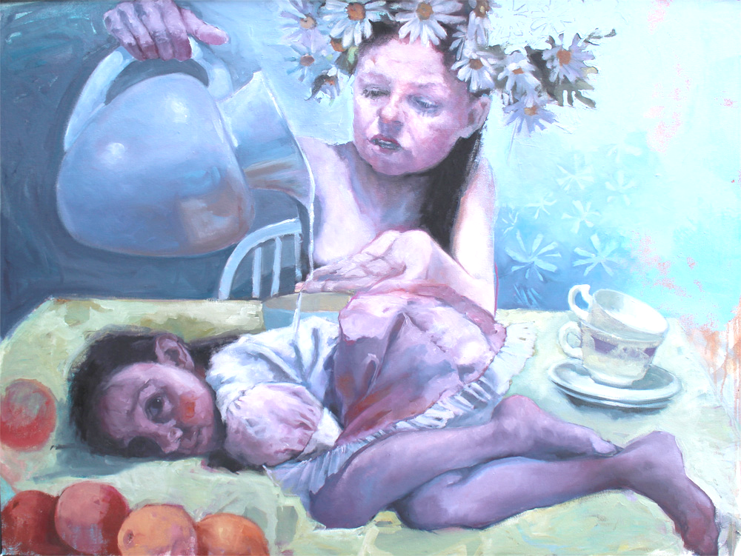
ARTS GARAGE, ATLANTIC CITY:
ATLANTIC CITY, NJ - The Noyes Arts Garage of Stockton University is proud to host its free monthly Second Friday event on Friday, Nov. 11 from 6 – 8 p.m. This reception celebrates the opening of three exhibitions: Noyes Signature Artist Members, Yujin Song, and the Stockton Students Art Club, and also includes a book signing by Daniel Doster-Mann, author of Abused Intimacy. Enjoy live music, light refreshments, and a wine tasting by the Iron Room.
Jude Harzer, Cleansing
Second Friday at the Arts Garage is a family-friendly free event. A craft project for all ages will be offered in the art workshop.

The annual Noyes Signature Artist Members Exhibition opens at the Arts Garage on Friday, Nov. 4 and runs through Jan. 8, 2017. Showcasing recent work by twenty-one outstanding artists from throughout New Jersey, it includes mixed-media, assemblage, painting, ceramics, furniture, and sculpture. Highlights include Jude Harzer’s Cleansing, a provocative painting featuring children as observers and guardians of inter-generational mythologies. Amy Evans’ In the Blue series of dream-like cyanotypes reflect upon the mythical quality of memories. Sheila Grabarsky’s Fantasy Garden is an abstract painting filled with light and color and is featured in a newly released film, American Pastoral. Bette Blank’s lively illustrative painting adds a bit of humorous storytelling to the exhibition.
Artists in the Noyes Signature exhibition: Geoffrey Agrons, Bette Blank, Amy Evans, Joanie Gagnon San Chirico, Sheila Grabarsky, Glen Guarino, Jude Harzer, Eileen Kennedy, Joyce Lawrence, Alice McEnerney-Cook, Lucretia McGuff-Silverman, Tony Migliaccio, Kristin Myers, Vincent Nardone, Laura Petrovich-Cheney, Isabella Pizzano, Lou Riccio, Miklos Sebek, Karen Starrett, Lou Storey, and Skeffington Thomas.
-more-
-continued from page 2-

Daniel Doster-Mann, a charismatic author and motivational speaker, will be on hand to sign his book, Abused Intimacy, during the November 11 Second Friday event at the Arts Garage. Growing up in a family battling with addiction, he was bullied and abused as a child. Doster-Mann has a passion for encouraging and inspiring people from all walks of life to be heard, understood and healed.
Yujin Song is a painter from Jeju, South Korea. Currently an exchange student at Stockton University, she is visiting from Jeju National University. Her artwork, on view at the Arts Garage from Nov. 5 – 29, is a form of documentation, capturing the moment of a personal connection or a strong emotion. “I switched from painting people to depicting places, after realizing that portraits limit my ability to tell a story,” Song states.

The Stockton Art Club Exhibition, in the Osprey Gallery at the Arts Garage, is on view from Nov. 5 – 29 and includes the work of talented Stockton University students. This exciting annual exhibition is curated and installed by the students themselves.
For more information call (609) 626-3805 or visit artsgarageac.com.

Current Exhibitions at the Noyes Arts Garage of Stockton University - Atlantic City:

- The African American Heritage Museum of Southern New Jersey:
JET, BLACK, BROWN and TAN: The Legacy of John H. Johnson Oct. 1 – Dec. 30
- The Noyes/Stockton Annex: Hak Vogrin: A Retrospective Aug. 5 – Oct. 30

- The Noyes/Stockton Gallery: Grand Vista: 21st Century Landscapes Aug. 5 – Oct. 30

- The Atlantic City Gallery:
FOCUS ON ECONOMIC INEQUALITY: A Community Exhibition Oct. 8 - 30
- The Osprey Gallery:
FOCUS ON ECONOMIC INEQUALITY: A Community Exhibition Oct. 8 - 30

-more-

-continued from page 3-
Upcoming Events at the Noyes Arts Garage of Stockton University - Atlantic City:

Watercolor Class with Stephanie Segal Miller, 2 – 4:30pm Oct. 30
Second Friday (The public is welcome: 2nd Friday of Every Month) Nov. 11
Free Social Media Workshop: 6:00 – 8:30pm Nov. 17
AC Craft Market: Small Business Saturday! Nov. 26

Current Exhibitions of the Noyes Museum of Art of Stockton University:

- Noyes Gallery at Stockton’s Kramer Hall, Hammonton:
Hammonton: 150 Years of Agriculture Aug. 22 – Dec. 31
- AtlantiCare Regional Medical Center - Healing Arts Program, Atlantic City Campus
Lou Storey: The Best Medicine Sept. 9 – Jan. 1, 2017
- Noyes Gallery at Stockton’s Seaview Resort in Galloway Township:
Pulp: Works from the Noyes Permanent Collection Sept. 1 – Jan. 8, 2017
Cathleen Engelsen: Paintings & Prints Sept. 1 – Jan. 8, 2017
About:
The Noyes Museum of Art was founded in Oceanville, NJ, in 1983 to collect, preserve, and exhibit American fine and folk art, with an emphasis on New Jersey artists and folk art forms. Today, the Noyes Museum’s exhibitions reflect the area’s cultural heritage, while also presenting significant artwork by regional and national artists working in a variety of media. The Noyes has expanded to include galleries in Hammonton, Atlantic City, and at Seaview Resort in Galloway. The Noyes Shop: Hammonton opened in 2008 and specializes in custom framing. The Noyes Gallery at Kramer Hall in Hammonton is the newest addition to the vibrant Arts District in Downtown Hammonton, and The Noyes Museum’s satellite exhibition spaces. It is located at 30 Front Street, Hammonton, NJ 08037. In February 2010, The Noyes Museum of Art formed a partnership with Stockton College (now Stockton University) to form The Noyes Museum of Art of Stockton University. Through a 2013 partnership with the CRDA, The Noyes Museum opened The Noyes Arts Garage of Stockton University, a unique multi-use arts and retail space at 2200 Fairmount Avenue in Atlantic City. # # #

